**DAYANANDA SAGAR COLLEGE OF ARTS, SCIENCE AND COMMERCE,**

**DEPARTMENT OF COMPUTER APPLICATIONS,**

**BANGALORE -111.**

**Master of Computer Applications**

**MCA 2023– 2025**

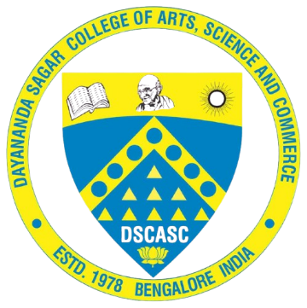

**A Project Report**

**On**

**WEB BASED LEARNING MANAGEMENT SOLUTION**

**Submitted by**

***RUDRAKSH KHATRI***

***(P03CJ23S126085)***

In partial fulfillment of the requirements for the award of the degree of **Master of Computer Applications**, Bangalore University.

Under the guidance of

**Prof. RUDRESHWARI G**

**Assistant Professor, DSCASC**

**DAYANANDA SAGAR COLLEGE OF ARTS,**

**SCIENCE AND COMMERCE**

**DEPARTMENT OF COMPUTER APPLICATIONS,**

**BANGALORE -111.**

**Master of Computer Applications**

**MCA 2023 – 2025.**

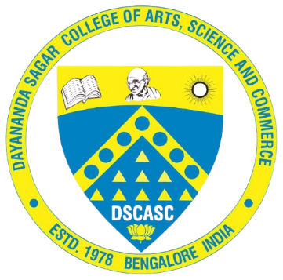

**CERTIFICATE**

This is to certify that RUDRAKSH KHATRI (P03CJ23S126085) of 4TH semester MCA, has satisfactorily completed the Project work during MONTH 2025 – MONTH 2025, entitled **“WEB BASED LEARNING MANAGEMENT SOLUTION”** in partial fulfillment of the requirements for the award of the degree of Master of Computer Applications under Bangalore University.

|  |  |
| --- | --- |
| **Prof. RUDRESHWARI G** | **Prof. Dr. Kumudavalli M V** |
| **Project Guide** | **Deputy Director** |
| **DSCASC** | **DSCASC** |
|  |  |
| Date: Signature of the Examiners: | 1. |
|  | 2. |